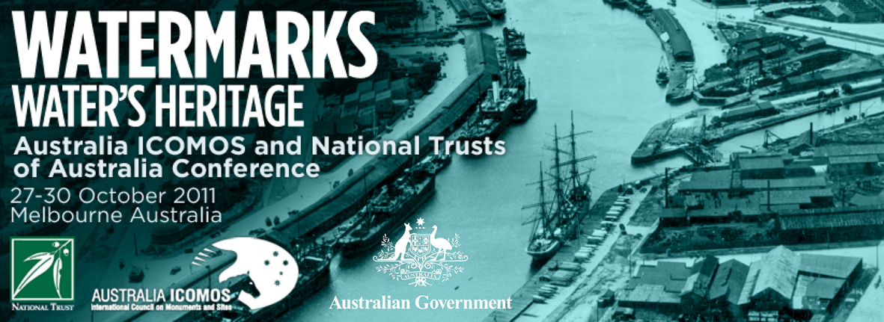

WATERMARKS PHOTOGRAPHY COMPETITION
Water and the places connected with its heritage are often very striking visually, so Australia ICOMOS and the National Trusts of Australia are pleased to be holding a photography competition in association with the Watermarks, Water’s Heritage conference. The conference will be held in Melbourne, 27-30 October 2011, and the categories for the photo competition will centre on three broad water-related themes.
The categories for the competition are:
- Celebrating water (recreation, water features, etc.)
- Working water (Indigenous use of water, water supply, aquaculture, agriculture, industry, transport)
- Imagining water in the landscape (natural and designed landscapes)
- Photo Essay (up to six images on any one of the three conference themes)
Entries will be displayed at the Melbourne Conference and Exhibition Centre throughout the conference. Voting in each category will be open to conference delegates. Prizes will be awarded on the second day of the conference, and the winning entries will then be showcased on the Australia ICOMOS conference website. Any winners not present at the conference will be notified by email. Entries will be available for collection at the conclusion of the conference or alternatively please include a suitable stamped self-addressed envelope if you want your print(s) returned by mail.
Entry Deadline
Competition entries must be submitted by Monday 17th October 2011 at the latest. Note: There is also an option to submit a complete electronic application by the above date, and then hand-deliver photographic prints to the conference venue at 8.30 am, Friday 28 October.

General Conditions of Entry
- The competition is open to all financial members of Australia ICOMOS, members of Australian National Trusts, and registered conference delegates.
- Entrants must complete a single Entry Form for all their entries.
- Entrants may submit up to four (4) entries, a maximum of one entry per category. One of these entries can be a photo essay of up to six images. Images can be taken in Australia or overseas.
- Entrants warrant to Australia ICOMOS and the National Trusts of Australia that: (a) the entered image is an original work of their own authorship; and (b) the entrant is the owner of the unencumbered copyright in the Work.
- Australia ICOMOS and the National Trusts of Australia reserve the right to accept or reject entries.
- Entrants grant Australia ICOMOS and the National Trusts of Australia an irrevocable and non-exclusive right to publish, reproduce and communicate entered image/s by any means. Australia ICOMOS and the National Trusts of Australia recognise that entrants retain copyright in the Work and may publish or authorise others to publish the entire Work or any part thereof. Australia ICOMOS and the National Trusts of Australia will ensure that appropriate credit is given to the author of the Work. There will be no financial or other remuneration for the use of the Work.
- If entrants do not grant Australia ICOMOS and the National Trusts of Australia an irrevocable and non-exclusive right to publish, reproduce and communicate entered image/s they must opt out by ticking the box on the entry form.
- All possible care will be exercised, but no responsibility will be assumed by Australia ICOMOS or the National Trusts of Australia for the loss or damage of entries in exhibition or in transit.

Print Requirements
- Images must be A4-format or smaller, printed on heavyweight (e.g., 220 to 250 gsm) photographic quality paper in matte, gloss or semigloss finish. Slides and negatives will not be accepted.
- Please do not mount or frame prints.
- There are two options for submission of entries and the required documentation:
  - Physical prints delivered (by hand or post) by 17 October 2011 to:
N Schmeder, Context P/L, 22 Merri Street, Brunswick VIC 3056.
Photos should be in a flat package (not rolled in a tube). They must be accompanied by: digital versions of the images on CD (in Jpeg or Tiff format, 500Kb to 2Mb in size) as well as an electronic Entry Form (Word format), and a printed and signed Entry Form; or
  - Submit an electronic application by 17 October 2011, emailed to:
Aaron Murphy – am@aaronmurphy.com.au
This will include digital versions of the images (in Jpeg or Tiff format, 500Kb to 2Mb in size) as well as an electronic Entry Form (Word format).
The prints and signed paper Entry Form must then be hand-delivered to the conference venue at 8.30 am, Friday, 28 October.
- On the Entry Form, give each entry a short title for display and citation purpose, as well as a descriptive caption giving brief details of the subject.
- The title of the image, the entrant’s name and email address or phone number must appear on the back of each print.
- Photo essays must be clearly marked as such and will be displayed and judged as a single entry. Please indicate display order if that is relevant.

Photography competition enquires to competition co-ordinator:
Aaron Murphy – am@aaronmurphy.com.au

WATERMARKS PHOTOGRAPHIC COMPETITION ENTRY FORM

Please complete details below for each entry and ensure you have included a suitable sized self-addressed envelope if you wish to have your photographs returned by post.

NAME OF ENTRANT:
CONTACT EMAIL:
CONTACT PHONE:
MEMBER OR DELGATE: | (indicate membership of Australia ICOMOS, a state National Trust, and/or conference delegate)

Category A: Celebrating water

Photo Title:
Description:

Category B: Working water

Photo Title:
Description:

Category C: Imagining water in the landscape

Photo Title:
Description:

PTO
Category D: Photo Essay

Essay theme (A, B or C):
Photo Title:
Description:
Photo Title:
Description:
Photo Title:
Description:
Photo Title:
Description:
Photo Title:
Description:
Photo Title:
Description:

I ________________________________ am submitting the above entry to the Watermarks Photographic Competition in agreement with the General Conditions of Entry.

_________________________________________ ___________________
(Signature of Entrant) (Date)

By entering the competition you are giving Australia ICOMOS and the National Trusts of Australia an irrevocable and non–exclusive right to publish, reproduce & communicate your images in any form. If you DO NOT want Australia ICOMOS and the National Trusts of Australia to have this right please tick the box.

Questions about the competition can be directed to Aaron Murphy by email am@aaronmurphy.com.au

