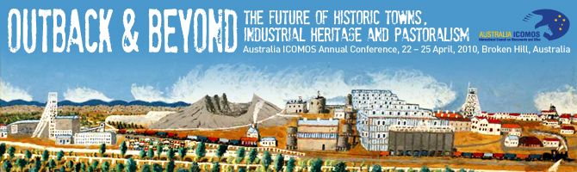
POSTER ABSTRACTS
Background
The Outback & Beyond Conference Committee now seeks submissions of abstracts for papers and snap-shot presentations. This is also a call for those seeking to display a poster during the 2010 conference.
Language: All posters are to be in English.
Submission review: All submissions will be reviewed by the Conference Papers Sub-group.
Poster deadlines
Deadline for submission to display a poster: Friday 30 October 2009
Notification of successful posters: Friday 4 December 2009
Deadline for displaying a poster: Thursday, 22 April 2010

Poster displays will be the responsibility of the person seeking to display the Poster. Posters are to be mounted at the commencement of the conference and to be removed at its conclusion. Please see the ICOMOS web site for poster dimensions and attachment details.

Submissions to be sent to bradley@ccem.com.au, Countrywide Conference & Event Management by Friday 30 October. Any general queries about the conference to be sent to stepowsk@tpg.com.au.

Posters displays are designed for persons who seek to show-case a specific site or project. Poster displays are to relate one or more of the three conference themes as follows:
- Day 1 - Managing historic towns
- Day 2 - Managing industrial heritage
- Day 3 - Managing remote pastoralism
Poster displays will be the responsibility of the person seeking to display, including obtaining prior content clearances where necessary. Poster display space is limited to an A1 page. Those seeking to exhibit a poster are to complete the Application Form on the following page.

Conference proceedings:
Posters will be displayed throughout the duration of the conference.

REFER TO THE APPLICATION FORM BELOW WHICH IS TO BE COMPLETED BY THOSE SEEKING TO DISPLAY A POSTER
POSTER – APPLICATION FORM

NAME OF PRESENTER:
TITLE OF POSTER:
CONTACT EMAIL:
THEME: (please tick) | □ Day 1 - Managing historic towns  □ Day 2 - Managing industrial heritage  □ Day 3 - Managing remote pastoralism
KEY THEME/ CONTENTS OF POSTER: (max 200 words)

BRIEF BIOGRAPHICAL INFORMATION ABOUT THE POSTER PRESENTER: (max 100 words)

Please forward to: bradley@ccem.com.au, Countrywide Conference & Event Management by Friday 30 October.

